Three-Dimensional Modeling of the Ferndale Site (45WH34)

Kate Ellenberger
Callie Moore

GIS Minor Final Project for EGEO 452
Spring 2009

Background

The Use of Geographic Information Systems in Archaeological Research

There has been a long history of spatial analysis in archaeology to understand artifact distribution and household layout patterns. While Geographic Information Systems (GIS) were developed initially for use on geographic and planning applications, common GIS tools can easily be adapted for use by archaeologists (Kantner 2008:48-51). Almost all information collected by archaeologists is referenced to a specific location so GIS is an ideal tool for working with this data.
Over the last twenty years the use of computerized tools in archaeological research has become widespread. As computers with greater processing capabilities that have become increasingly accessible, archaeologists have adapted their spatial analysis techniques to make the most of it (Kantner 2008:47). Traditionally spatial analyses in archaeology were only practical for studies in limited spatial contexts so using the computing power that became available in the 1990s archaeologists were able to expand the scope of their analyses (Koetje 1991). In the last ten years, as the storage capacity of computers has rapidly improved, storing excavation data in relational databases has quickly become the standard (Kantner 2008:62).
Site modeling and visualization is a common use of GIS in archaeology. Although graphical products are not analytical conclusions themselves, they are powerful tools that can enable researchers to identify patterns that might not otherwise be noticed (Kvamme 1999:160-162). Using the computing power and relational databases on which GIS are based it is feasible to look at archaeological sites across entire landscapes to better understand where sites are likely to occur, a scale of analysis that was not practical before (Kantner 2008:49-52; Kvamme 1999:162-181).
Significant strides have also been made in visualization techniques that do not disturb cultural resources. Using magnetic gradiometers, ground penetrating radar instruments and electrical resistivity meters, data can be collected about natural and man-made features below the surface without significantly disturbing the ground. The data collected with these instruments can be used in addition to excavation data to understand prehistoric peoples’ use of the landscape (Bevan 1983; Conyers and Cameron 1998; Klasner and Calengas 1981; Kvamme 2003); often these instruments detect features below the ground surface that are not detectable during excavation such as magnetism left behind by burning. Laser instruments are also used, particularly by archaeologists studying classical civilizations, to obtain very precise data about the shape of prehistoric structures (Kvamme 1999:183). These high-tech visualization tools have made it possible to create the kinds of visually stunning, interactive displays that excite the public about archaeological research.
Unfortunately, much of the data that remains to be analyzed was collected before remote sensing and GIS were available to most archaeologists. This means that archaeologists who want to use GIS to visualize sites need to adapt excavation records from the past – often reflecting outdated standards of excavation – to fit the requirements of today’s computerized tools. Because observations from many individuals make up a body of knowledge about a site it can be difficult to convert these documents to a format that is usable in GIS. It is important that data from sites excavated in the past are adapted to be used in GIS so that they can be analyzed, visualized and made available for comparison to other, more recently excavated, archaeological sites.

The Ferndale Site

The Ferndale Site (45WH34) is an archaeological site in the town of Ferndale in Whatcom County, Washington. Lying on the active floodplain of the Nooksack River, the area surrounding the site is rich in floral and faunal resources which have made it attractive to potential inhabitants for thousands of years.
Materials found at this site have been radiocarbon dated between 5,300 and 4,400 years ago. Sites from this time period typically constitute seasonally occupied hunter-fisher-gatherer base camps where a wide range of resources are utilized (Gillis 2007:10). The artifact assemblage at the Ferndale site is dominated by expedient stone tools, while similarly expedient bone, antler, shell and ground stone tools are also present.
Excavation of this site was performed by Dr. Garland Grabert and a crew from Western Washington University in 1972. Records from the excavation include catalogues describing artifacts and soil samples as well as profile drawings of the walls of most excavated areas. These are especially useful for determining periods of continuous site occupation after excavation is completed as they distinguish between natural and seemingly human-modified soil strata.
In 2003, Dr. Sarah Campbell and a number of her graduate students at Western Washington University decided to take a second look at the 45WH34 collections which had remained largely untouched since the mid-1970s. The unusually high concentration of well-preserved bone and antler artifacts made the site a good candidate for intensive study as it could significantly impact archaeologists’ understanding of Northwest Coast prehistory.
Now that most of the artifacts in the collection have been researched in great depth, Dr. Campbell is working to piece together the story of the site as a whole. In doing so it has been difficult to visualize the relationships between excavated units, soil strata and artifacts using the paper records created by Grabert. Using the GIS tools that are available today, it is possible to significantly improve the process of visualizing and synthesizing data from 45WH34.

Goal of Study

Like many universities, the majority of the archaeological collections at Western Washington University come from sites which were excavated before relational databases were widely used. The first step in bringing these collections into GIS is to display the layout of the excavation as a whole in a computer model. The resulting three-dimensional model of these sites can be used by researchers to better visualize the layout of the site and the places where humans occupied it.
The Ferndale Site is an ideal candidate for the creation of a three-dimensional site model due to its antiquity and the level to which it has been studied. The goal of this project is to create a computerized model of the site that displays excavation unit wall drawings (from here on, profiles). This model will serve as a tool for Dr. Sarah Campbell as she develops a publication telling the archaeological story of what occurred at the site.

Methods

Data

Data used in this project are the original archaeological site map drawn by Dr. Garland Grabert (Figure 1) and profile drawings by his field crew. The site map includes the locations of stakes that make up the grid system he set up and the locations of the excavated areas throughout the site. This map was used primarily as a reference for the placement of features in the 3D model.

Figure 1. Map by Dr. Garland Grabert showing excavated areas (squares) and surveyed points (points) (Garland Grabert, 45WH34 The Ferndale Site Local Topography Map, Department of Anthropology, Western Washington University, Bellingham, WA)

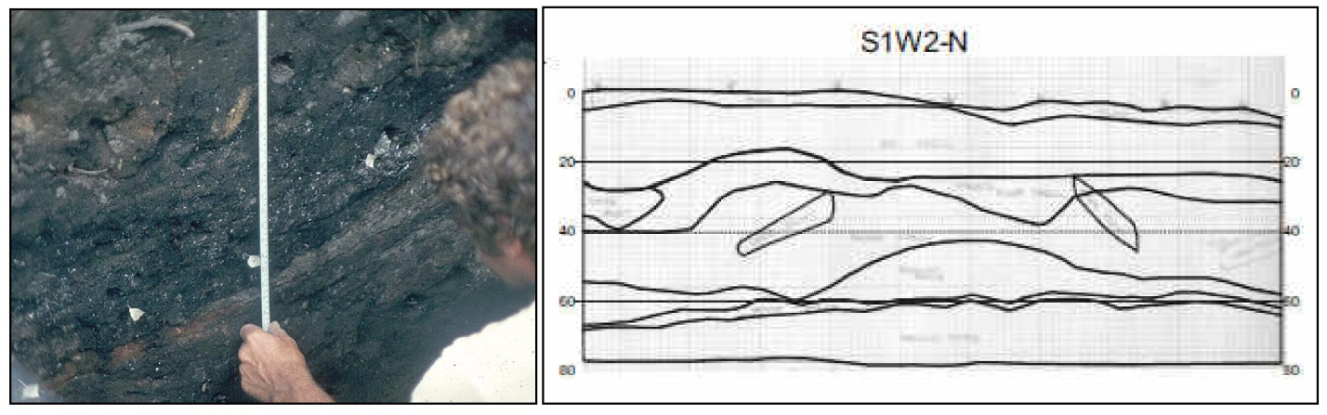
Figure 2. (Left) Photograph of measurements being taken during profile drawing process; (Right) Example of a profile drawing showing the North wall of unit S1W2 created by Nichole Gillis

Profile drawings made for walls of each excavation unit are the primary dataset for this project. Most have been scanned and their legends standardized by Nichole Gillis (Figure 2), but they will need to be edited further to display properly in a 3D model.
Gillis also estimated the ground surface at the corners of each excavated unit (Nichole Gillis, Thesis preparation materials, Department of Anthropology, Western Washington University, Bellingham, WA). This was used as a supplemental data source during the final estimation of the corner heights.
All these data were needed to visualize this site successfully. Due to inconsistencies in measurements made in the field, the profile drawings in particular needed to be critically examined and re-evaluated to determine the ground level for the corners of each excavated unit.

Study Area

The study area is the Ferndale site, an archaeological site that was utilized by prehistoric Native peoples between 5,300 and 4,400 years ago. According to the current understanding of this time period by archaeologists, this site was likely used as a seasonal base camp during the winter while inhabitants subsisted on resources gathered during the warmer months (Gillis 2007:10).

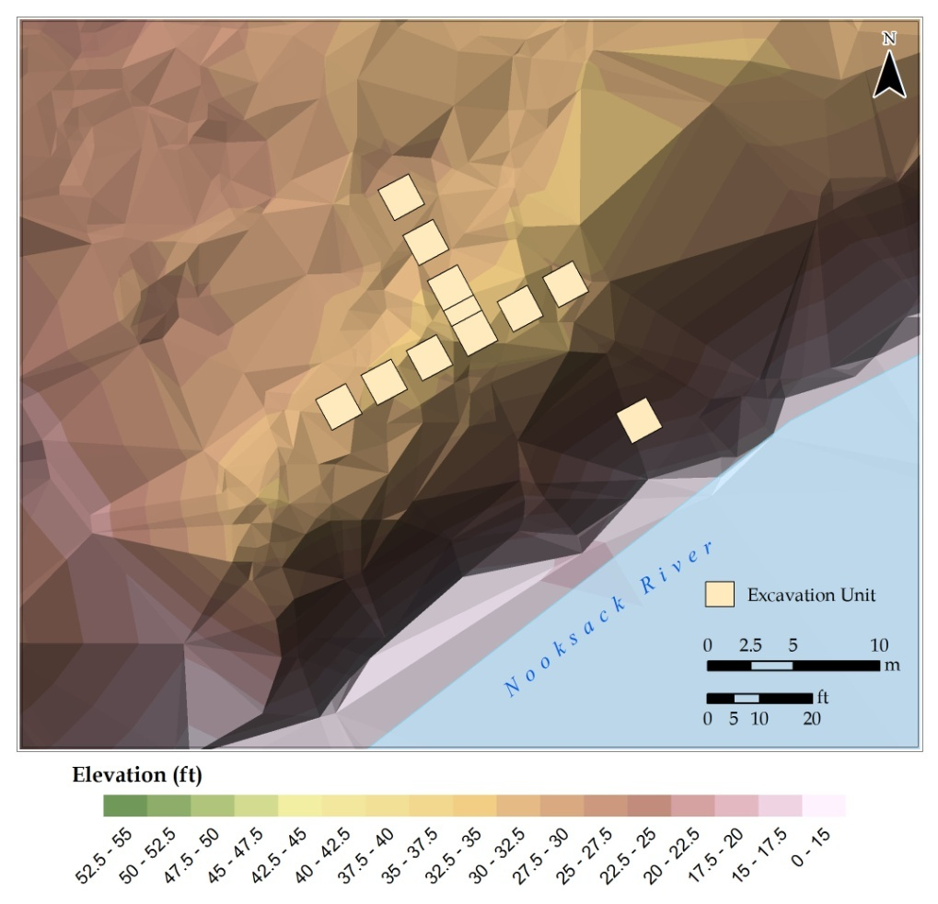

Figure 3. The Ferndale site excavation layout, displayed here with a terrain model
created from LIDAR imagery collected by Lummi Nation in 2006

As described above, the Ferndale site lies on the active floodplain of the Nooksack River, an area that undergoes constant erosion and sedimentation (Figure 3). The three-dimensional model created during this project will be the first view of the site as a whole, as it was in 1972, which has been seen since the excavation. The distribution of the many artifacts and soil features that were found during excavation will be easier than ever to visualize, giving researchers the time to explore them more extensively.

Process

The process that was used to create a three-dimensional model of the Ferndale site required extensive re-evaluation of excavation records. In order to come up with the best estimate of the ground height at each corner of the excavated units, the analysis was broken into three parts:
1. Measured ground surface height based on original profile drawings
2. Measured ground surface height based on profiles standardized by Nichole Gillis
3. Reviewed estimation of ground surface by Nichole Gillis

The ground height was measured for parts 1 and 2 based on the relationship of the ground level to features with known elevations. This was done twice for the corners of each excavated unit.
With the original profiles, the ground surface at a given corner was measured from each stake in the drawing. The height at the corner was calculated using the known ground surface height at the base of that stake. If the measurements of the same corner from the two stakes were inconsistent, adjustments were made to “split the difference” of that inconsistency. The procedures used to do so are as follows:
- If one of the stakes drawn in the profile represents the stake closest to the Northwest corner of the excavated unit the measurement from that stake was favored because, according to the excavation notes, that was the point from which all depth measurements used in profile drawings were taken (Garland Grabert, 45WH34 Excavation Notes, Department of Anthropology, Western Washington University, Bellingham, WA).
- If the Northwest stake was not represented in the original drawing (when it is not a drawing of the North or West walls) and the depth measurements for an excavation unit corner depicted in the drawing is different when measured from the two stakes in the drawing, a compromise was made between the disparate measures. All adjustments were made so that the relative heights of the corners in a single profile was maintained, ensuring proper display in the 3D model.
- If the height of a corner measured from one profile drawing is inconsistent with the height of that same corner measured from a different profile drawing, an adjustment similar to the one described above must be made for all effected profiles.

The analysis process was different working with the profiles standardized by Gillis. The corner elevation was measured off of the “0” baseline which represents the height of the Northwest stake on the Gillis profiles. When the height calculated for a corner was inconsistent with the height for that same corner in another profile, adjustments were made similar to those used when working with the original profiles.
After adjustments were made across the entire dataset, the heights of the corners were compared to the ground height at the nearest surveyed stake. Where these were significantly different, the profile was revisited to make sure that the measurement of the corner was done accurately. This process resulted in a consistent and seemingly reasonable estimation of the topography of the site at the time of excavation.
Final heights were determined by comparing the estimations from each of the three data sources. The measurements made during this project were favored over Gillis’ estimations (2006) as the measurement process is known and consistent. When multiple data sources could be used in estimation, the original profile drawings were treated as the most reliable source of information. When there was no other information, the elevation of the nearest surveyed point was used.
Image processing began once the elevations of the unit corners were determined. All profile images were cropped to allow them to be fitted into the smallest rectangular area possible. Using the top left corner of each profile as a reference point, the height of the cropped profile image was determined. (This step was taken in order to prepare the images to display in ArcScene, a program which was eventually abandoned. Using this information, further image processing steps were needed for the model to be successfully rendered using the alternative program, Google SketchUp.)
In order for the processed images to accurately display in a Google SketchUp model, the bottom left corner of the images must represent the same elevation. To solve this problem all the images were put into a box with a standard size and resolution, the bottom of which represented a fixed elevation (8.25 meters above sea level). The box was 800 pixels wide and 1100 pixels high, allowing for future vertical adjustment of the profile drawings in the model. The resolution and width of all images were standardized before being put into the box. A Google SketchUp model was then created using Grabert’s 1972 site map as a reference. This model represents the horizontal layout of the excavated areas of the site to scale. Profile images were imported into the model and positioned in the appropriate locations.

Results

The data collected from the three data sources were compiled into a data table (Table 1) so that a final determination of the ground surface height across the site could be made. The approximate height at each point in relation to the site datum and in relation to sea level was recorded in the table.

Table 1. Data about ground surface height collected through analysis of Ferndale Site excavation records and thesis by Nichole Gillis, including final estimations of ground level at each point based on data collected with respect to site datum and sea level
Unit | Corner | Corner Northing | Corner Easting | NW Stake Height Above Datum (m) | Height Above Datum (m) -- from Gillis profiles | Height Above Datum (m) -- from original profiles | Height Above Datum (m) -- Gillis estimate | Final Decision -- Height Above Datum (m) | Height Above Sea Level (m)
Datum | n/a | n/a | n/a | n/a | n/a | n/a | n/a | 0.00 | 9.60
N0W4 | NE | 0.5 | -9.5 | 0.51 |  | 0.30 | 0.62 | 0.30 | 9.90
N0W4 | NW | 0.5 | -11.5 | 0.51 | 0.53 | 0.34 | 0.55 | 0.53 | 10.13
N0W4 | SE | -0.5 | -9.5 | 0.51 |  | 0.57 | 0.58 | 0.57 | 10.17
N0W4 | SW | -0.5 | -11.5 | 0.51 | 51.00 |  | 0.51 | 0.51 | 10.11
N1W4 | NE | 2.5 | -9.5 | 0.47 |  | 0.48 | 0.48 | 0.48 | 10.08
N1W4 | NW | 2.5 | -11.5 | 0.47 | 0.50 |  | 0.47 | 0.50 | 10.10
N1W4 | SE | 0.5 | -9.5 | 0.47 |  | 0.30 | 0.58 | 0.30 | 9.90
N1W4 | SW | 0.5 | -11.5 | 0.47 | 0.53 |  | 0.51 | 0.53 | 10.13
N2W4 | NE | 5.5 | -9.5 | 0.18 | 0.25 | 0.30 | 0.31 | 0.25 | 9.85
N2W4 | NW | 5.5 | -11.5 | 0.18 | 0.32 | 0.26 | 0.18 | 0.32 | 9.92
N2W4 | SE | 3.5 | -9.5 | 0.18 | 0.35 | 0.48 | 0.48 | 0.35 | 9.95
N2W4 | SW | 3.5 | -11.5 | 0.18 | 0.42 | 0.38 | 0.47 | 0.42 | 10.02
N3W4 | NE | 8.5 | -9.5 | 0.04 |  |  | 0.08 | 0.04 | 9.64
N3W4 | NW | 8.5 | -11.5 | 0.04 | 0.06 | 0.06 | 0.04 | 0.06 | 9.66
N3W4 | SE | 6.5 | -9.5 | 0.04 |  |  | 0.31 | 0.04 | 9.64
N3W4 | SW | 6.5 | -11.5 | 0.04 |  | 0.24 | 0.18 | 0.24 | 9.84
S1W2 | NE | -0.5 | -3.5 | 0.51 | 0.44 | 0.29 | 0.46 | 0.44 | 10.04
S1W2 | NW | -0.5 | -5.5 | 0.51 | 0.51 | 0.37 | 0.51 | 0.51 | 10.11
S1W2 | SE | -2.5 | -3.5 | 0.51 | 0.38 |  | 0.76 | 0.38 | 9.98
S1W2 | SW | -2.5 | -5.5 | 0.51 | 0.46 |  | 0.40 | 0.46 | 10.06
S1W3 | NE | -0.5 | -6.5 | 0.58 | 0.42 | 0.38 | 0.51 | 0.42 | 10.02
S1W3 | NW | -0.5 | -8.5 | 0.58 | 0.58 | 0.44 | 0.58 | 0.58 | 10.18
S1W3 | SE | -2.5 | -6.5 | 0.58 | 0.32 | 0.28 | 0.40 | 0.32 | 9.92
S1W3 | SW | -2.5 | -8.5 | 0.58 | 0.40 | 0.46 | 0.50 | 0.40 | 10.00
S1W4 | NE | -0.5 | -9.5 | 0.51 |  | 0.57 | 0.58 | 0.57 | 10.17
S1W4 | NW | -0.5 | -11.5 | 0.51 | 0.51 |  | 0.51 | 0.51 | 10.11
S1W4 | SE | -2.5 | -9.5 | 0.51 |  | 0.47 | 0.50 | 0.47 | 10.07
S1W4 | SW | -2.5 | -11.5 | 0.51 | 0.37 |  | 0.39 | 0.37 | 9.97
S1W5 | NE | -0.5 | -12.5 | 0.44 | 0.44 |  | 0.51 | 0.44 | 10.04
S1W5 | NW | -0.5 | -14.5 | 0.44 | 0.29 |  | 0.44 | 0.29 | 9.89
S1W5 | SE | -2.5 | -12.5 | 0.44 | 0.36 |  | 0.39 | 0.36 | 9.96
S1W5 | SW | -2.5 | -14.5 | 0.44 | 0.34 |  | 0.31 | 0.34 | 9.94
S1W6 | NE | -0.5 | -15.5 | 0.33 | 0.45 |  | 0.44 | 0.45 | 10.05
S1W6 | NW | -0.5 | -17.5 | 0.33 | 0.33 |  | 0.33 | 0.33 | 9.93
S1W6 | SE | -2.5 | -15.5 | 0.33 | 0.29 |  | 0.31 | 0.29 | 9.89
S1W6 | SW | -2.5 | -17.5 | 0.33 | 0.31 |  | 0.28 | 0.31 | 9.91
S1W7 | NE | -0.5 | -18.5 | 0.29 | 0.29 |  | 0.33 | 0.29 | 9.89
S1W7 | NW | -0.5 | -20.5 | 0.29 | 0.24 |  | 0.29 | 0.24 | 9.84
S1W7 | SE | -2.5 | -18.5 | 0.29 | 0.28 |  | 0.28 | 0.28 | 9.88
S1W7 | SW | -2.5 | -20.5 | 0.29 | 0.21 |  | 0.23 | 0.21 | 9.81
S4W2 | NE | -9.5 | -3.5 | -0.16 |  |  | -0.16 | -0.16 | 9.44
S4W2 | NW | -9.5 | -5.5 | -0.16 |  |  | -0.16 | -0.16 | 9.44
S4W2 | SE | -11.5 | -3.5 | -0.16 |  |  | -0.16 | -0.16 | 9.44
S4W2 | SW | -11.5 | -5.5 | -0.16 |  |  | -0.16 | -0.16 | 9.44
Highlighted text shows where a final decision was based solely on the elevation of the nearest surveyed point.

Once the images were imported into the SketchUp model, a new visualization of the site was attained (Figure 4).
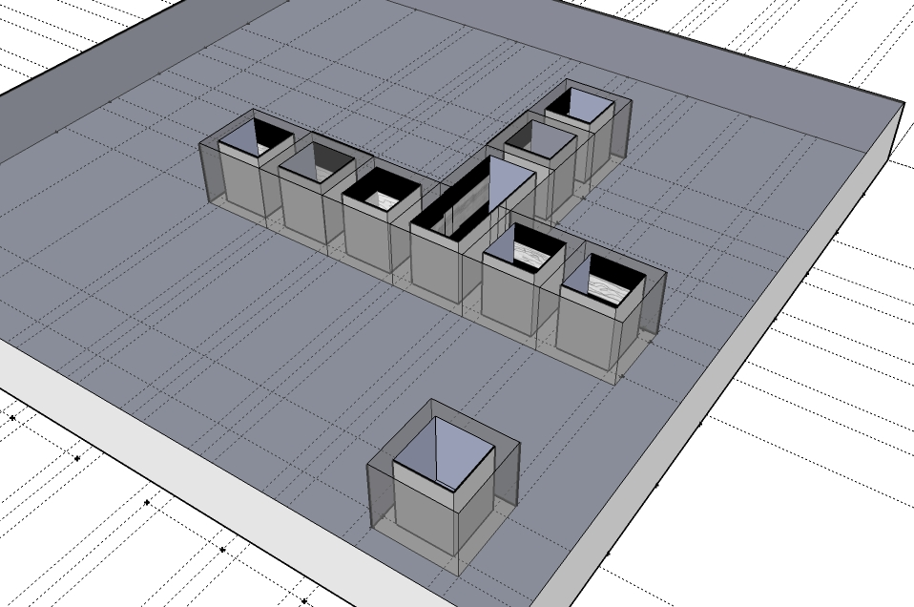
Figure 4. Three-Dimensional model of 45WH34 excavation and profile drawings made using Google SketchUp

Discussion

Significance of Results

The analysis undertaken here sheds significant light on the consistency of the data collected during excavation of 45WH34. While gaining access to these data was not a problem, determining the role that each would play in the creation of the model was challenging. The data that was collected about the excavated areas was limited and the data sets inconsistent. Comparing data collected by different people for different purposes, the strengths and weaknesses of each source have become obvious. This is particularly true for the materials produced by Gillis.
For each excavated unit, Gillis strived to standardize the vertical measurements in order to reconstruct the stratigraphic relationships to make sense of the soil formations at 45WH34 (Nichole Gillis, personal communication 2009). This approach to reconstruction uses information collected on soils to inform the placement of the profiles and makes identifying man-made strata easier for archaeologists. The weakness of this approach is that the ground surface height of the resulting model is likely significantly inconsistent with the topographic data collected by the excavators.
While it was not the goal of her thesis, Gillis did estimate the ground surface elevations at the excavation unit corners. This estimation was used as ancillary data here. It is not clear how the Gillis estimates were made but the values assigned many unit corners appear to be reiterations of the nearest surveyed point. The estimations of the ground surface height made here by viewing Gillis’ profiles at close magnification were at times significantly different than the determinations Gillis herself made according to the table she provided. For these reasons Gillis’ estimation was taken as another dataset but was not used as a replacement for analyzing the original drawings.
Through revisiting the excavation data and previous studies done on this excavation, this analysis has also made it clearer what information is available to other researchers about the site. Because excavation of the 45WH34 took place in a time before general standards of excavation were agreed upon in American archaeology so knowing how the Ferndale Site records differ from what is expected from current excavations is valuable.

Revisiting the Methods

The process of measuring the profiles took the vast majority of the time spent on this project. Each archaeological site has a unique layout and a unique set of records. It was necessary to spend as much time looking over the excavation records as possible and trying to understand how those records can inform a three-dimensional model of the excavation. Certainly this is the most important step for any researcher who wants to create a three-dimensional model of an archaeological site and ideally would not be subject to a time limit. After all, without an intimate understanding of the data sources it is quite difficult to extract meaningful data out of them.
One of the weaknesses of the methods used in this project was the display of the three-dimensional model itself. The two programs used – Google SketchUp and ESRI ArcScene – had very different strengths. It was simple to make a three-dimensional model of the excavation using SketchUp without having to convert measurements made in the site-specific coordinate system. The disadvantage of using SketchUp is that there is not a way to adjust the size of imported images in a model, so all profile images had to be extensively processed to get them to display properly in the site model.
The visualization tools in ArcScene are much more flexible and it was expected that it would be the primary program used here. Even though importing, positioning and resizing images as symbols was a function built into the program, getting even one profile drawing to display properly was difficult if not impossible. It is unclear why this function did not work, but it is possible that each image would need to be imported and georeferenced as a raster dataset to display properly. That amount of data processing was not within the scope of this project.

Future Directions

The next steps in visualizing the Ferndale Site are likely to include the refinement of the three-dimensional model itself and modeling the landscape surrounding the site. During excavation, Dr. Grabert surveyed the land surrounding the site using a transit and drew a map showing contours derived from this data. To add another source of data to approximate the ground level at the excavation unit corners, the original transit data could be turned into a Triangulated Irregular Network (TIN) for use as a reference. This TIN could be used to interpolate a continuous surface as well. Either of these data would be helpful in approximating the ground surface at the site with a greater degree of accuracy.
A TIN or surface model created using survey data could also be used as visualization tools, helping archaeologists envision the site as it existed during the excavation. While there is a detailed terrain model available for the area surrounding the site, the data it was derived from was collected only two years ago. Given that the site lies on an active floodplain it is unlikely that the ground surface is the same now as it was during the excavation. If greater data resolution is desired, approximations of ground surface made in this project could be included in the creation of the TIN or surface model.
Another way to improve this model significantly would be to determine the UTM coordinates of the actual datum point, or some point on the site. This way the model created here can be imported into a GIS and situated on the landscape, allowing archaeologists to assess its true spatial relationship to other archaeological sites the area.

Conclusion

The approach in this analysis was to use the ground surface height information collected with the transit and drawn in the profile drawings to come up with an approximation of where the drawings are located in three-dimensional space. As the ground surface is one of the only features of the site that was measured in multiple capacities, using that information as a starting point seems to make the most sense. The primary three-dimensional model created here using the ground surface data can be adjusted later so that soil strata line up satisfactorily. Refining this model using additional data sources and expertise will only improve the approximation of the true spatial layout of the site.
There is no shortage of archaeological data that has been sitting for decades, unanalyzed. I believe that visualization is the first step in encouraging archaeologists to revisit excavation records from the past as is done here. If a clear and accessible method for three-dimensional site visualization were made available in the archaeological community it is likely that many more spatial analyses would be conducted on previously excavated sites. The Ferndale Site modeling project has by no means provided such a clear and accessible method, however it represents a first step toward the development of an archaeological visualization process.

References Cited

Bevan, Bruce W.
1983 Electromagnetics for Mapping Buried Earth Features. Journal of Field Archaeology 10(1):47-54.

Conyers, Lawrence B. and Catherine M. Cameron
1998 Ground-Penetrating Radar Techniques and Three-Dimensional Computer Mapping in the American Southwest. Journal of Field Archaeology 25(4):417-430.

Gillis, Nichole
2007 An Investigation of Charles Culture Housepit Deposits at the Ferndale Site (45 WH 34). M.A. Thesis, Department of Anthropology, Western Washington University.

Kantner, John
2008 The Archaeology of Regions: From Discrete Analytical Toolkit to Ubiquitous Spatial Perspective. Journal of Archaeological Research 16(1):37-81.

Klasner, John S. and Peter Calengas
1981 Electrical Resistivity and Soil Studies at Orendorf Archaeological Site, Illinois: A Case Study. Journal of Field Archaeology 8(2):167-174.

Koetje, Todd
1991 Simulated Archaeological Levels and the Analysis of Le Flageolet II, the Dordogne, France. Journal of Field Archaeology 18(2):187-198.

Kvamme, Kenneth L.
1999 Recent Directions and Developments in Geographic Information Systems. Journal of Archaeological Research 7(2):153-201.
2003 Geophysical Surveys as Landscape Archaeology. American Antiquity 68(3):435-457.

